TTW INC
WinMan Accounting
WinMan 7.0

TTW
5/1/2008

Contents
Overview 4
WinMan Accounting Calendar 5
WinMan Account Structure 6
GL Divisions 6
GL Departments 7
GL Account Types 8
Chart of Account 8
Account Defaults 9
Sub-ledgers 14
Accounts Receivable 15
Accounts Payable 16
Goods Shipped Not Invoiced (GSNI) 17
Goods Received Not Invoiced (GRNI) 18
Cash 19
Inventory 20
WIP 21
Financial Statement Set-up 22
Balance Sheet 23
Income Statement 24
Statement of Cash Flow (Optional) 25
Accounting Transactions – Sales 26
Sales Order 27
Shipment 28
Create an Invoice from a shipment 29
Create a Credit 30
Accounting Transactions – Purchasing 31
Purchase Orders 32
Matching the Voucher to the Goods 34
Cash Received 35
Cash Payment 36
Manufacturing Orders 37
Stock Movements 40
Inventory Adjustments 41
Consumable Materials 42
Fixed Assets 43
Closing Periods 44
Closing a Year 45
Over-Ride system settings to post previous transactions 45

Overview

WinMan is a fully integrated accounting system. Correct set-up of the accounting requirements is essential to providing accurate financial data.

WinMan is used in many different accounting structures. From a single company with one division to multiple companies with multiple divisions WinMan can be configured for many structures.

The General Ledger is fully integrated within WinMan. All entries are posted automatically by means of the GL Posting option found within the WinMan Utilities program. The only exception to this rule is a Journal entry which posts in real time. WinMan Utilities can be set up to run automatically at any time, and can also be run manually if required.

WinMan maintains values for all General ledger transactions according to accounting period, accounting year and chart of account entry. The GL transactions are linked to their corresponding tables to allow users to drill down for further detail.

WinMan Accounting Calendar

WinMan uses a date based financial calendar. When an entry in WinMan is made, the Calendar is used to determine which accounting year and accounting period should be used for the posting in the GL.

TIP: When starting out on WinMan, the accounting calendar must be created as the FIRST item before the implementation can begin.

The Accounting Calendar can typically be found using the Navigation Menu AccountingStanding Data Accounting Calendar. The Actions panel has all the existing years which can be accessed by clicking on a specific year. To create a new accounting calendar, select the action to Add New Year.

The data entry wizard will prompt for the following;

- Start date for new calendar year
- How many periods there will be

WinMan will then suggest beginning and end dates for each period based on the above criteria. These should be reviewed before proceeding as once the calendar is created, a date’s period can not be altered.

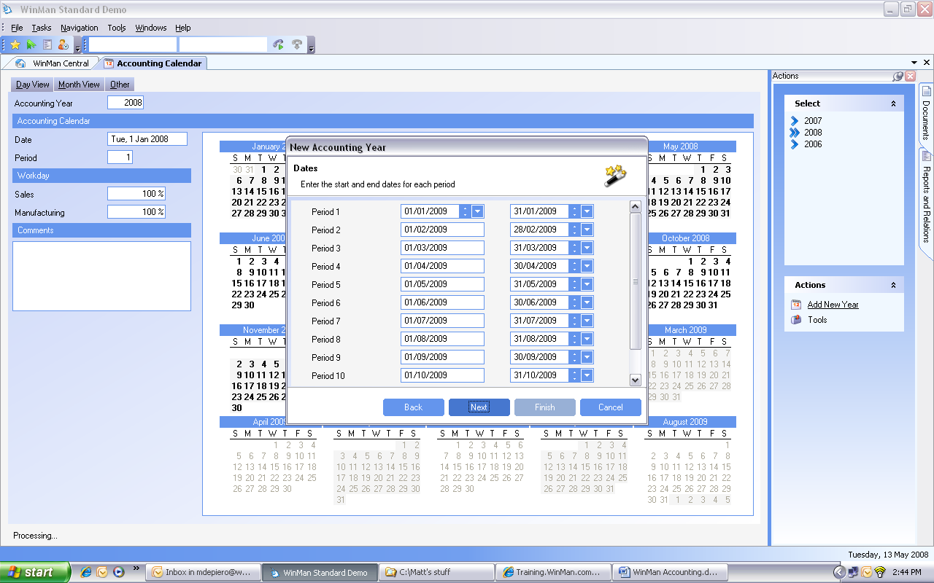
WinMan Account Structure

An account as found in the WinMan chart of accounts has 3 elements to it. The GL division, GL account type, and GL department and is built in this order. A typical account may look something like 01.100100.00. In this example 01 represents the GL division, 100100 represents the GL account type, and 00 represents the GL department.
The initial chart of accounts is typically imported as part of the WinMan implementation. However, all 3 elements (divisions, types, and departments) can be amended at any time. Once an account has any activity, it may not be deleted.

TIP: Once the accounting calendar is created, the chart of account is the SECOND thing that must be completed in the WinMan system prior to implementation.

GL Divisions

GL divisions are used to separate financial data on both the balance sheet and the income statement. Divisions represent a fundamental allocation of the results of activities between clearly identifiable areas of activity. These activity boundaries may be geographical or activity based but care should be taken not to create more than is required and to carefully plan out the divisional split required.

We suggest that if you have multiple divisions, the default division be set to the lowest number (ie. 00 or 01). This will help when printing and reviewing your chart of accounts and adding new divisions later

GL Divisions can be accessed from the GL divisions program found under Accounting Standing Data GL account divisions. GL divisions can be added at any time, however, if a division is to be deleted, it can not be associated with any chart of account, and not have any activity in the GL.

SYSTEM SETTING: The default GL division length in WinMan is 2 characters. This can be altered from System Options Options Chart of Accounts. Select the option for GL account division length ID, set the new length, and enable the option. This should be done prior to the chart of account being set up. If an adjustment to the length is needed once you are actively using WinMan, consult your WinMan representative. Maximum length for a GL division is 5 characters.

GL Departments

GL departments can be used with accounts on the income statement, however, they are not used with accounts on the balance sheet. GL departments are used to allocate expenses within an account type. Typical GL departments would be Sales, R&D, and Admin. While a default GL department is required, additional GL departments are not.

GL Departments can be accessed from the GL departments program found under Accounting Standing Data GL account departments. GL departments can be added at any time, however, if a department is to be deleted, it can not be associated with any chart of account, and not have any activity in the GL.

SYSTEM SETTING: The default GL department length in WinMan is 2 characters. This can be altered from System Options Options Chart of Accounts. Select the option for GL account department length ID, set the new length, and enable the option. This should be done prior to the chart of account being set up. If an adjustment to the length is needed once you are actively using WinMan, consult your WinMan representative. Maximum length for a GL department is 5 characters

GL Account Types

The GL account type is the body of the account number. Typically, the account numbers fall into a logical order where the starting number of the account represents where the account is to be located;

1 – Assets eg 100100 is an inventory account
2 – Liabilities eg 200000 is an Accounts Payable account
3 – Equity eg 300100 is Shareholders stock
4 – Sales eg 400100 is Sales – electrical devices
5 – Cost of sales 500100 is Cost of Sales – electrical devices
6 – Expenses – 670300 is Electricity

GL account types can be accessed from the GL account types program found under Accounting Standing Data GL account types. GL account types can be added at any time, however, if a type is to be deleted, it can not be associated with any chart of account, and not have any activity in the GL.

SYSTEM SETTING: The default GL account length in WinMan is 6 characters. This can be altered from System Options Options Chart of Accounts. Select the option for GL account division length ID, set the new length, and enable the option. This should be done prior to the chart of account being set up. If an adjustment to the length is needed once you are actively using WinMan, consult your WinMan representative. Maximum length for a GL account type is 15 characters.

TIP: In cases where accounts from a previous system are being brought over to WinMan, and the accounts are less than 6 characters, we recommend adding zeros to the end of the account and using at least the 6 characters as this will provide flexibility should additional account need to be added.

Chart of Account

The chart of account is built using the GL account types program. The chart can be built one account at a time, or using a mass build. A manual build can be done by accessing the account type, and selecting Add Item. Select the division and department required in the chart of account. This will build a chart of account one at a time.

To build a char in mass, select the action Generate Chart. A dialog will appear where a separate tab will exist for Division, Account and Department (Note the check/uncheck all function at the bottom of the dialog). Select from each of the 3 elements and chart of account records will be created for all combinations selected.

Account Defaults

There are a number of default accounts that are required to be populated before transactions can begin in WinMan. These defaults can be found in the System Options program (Administration Standing Data System Options ).

Defaults Tab

Mispostings Account

This is the account that if WinMan tries to post to a chart of account that does not exist, it will post here. We recommend creating an account type of 999999 be created and utilized with the default GL division and default GL department (eg 01.999999.00).

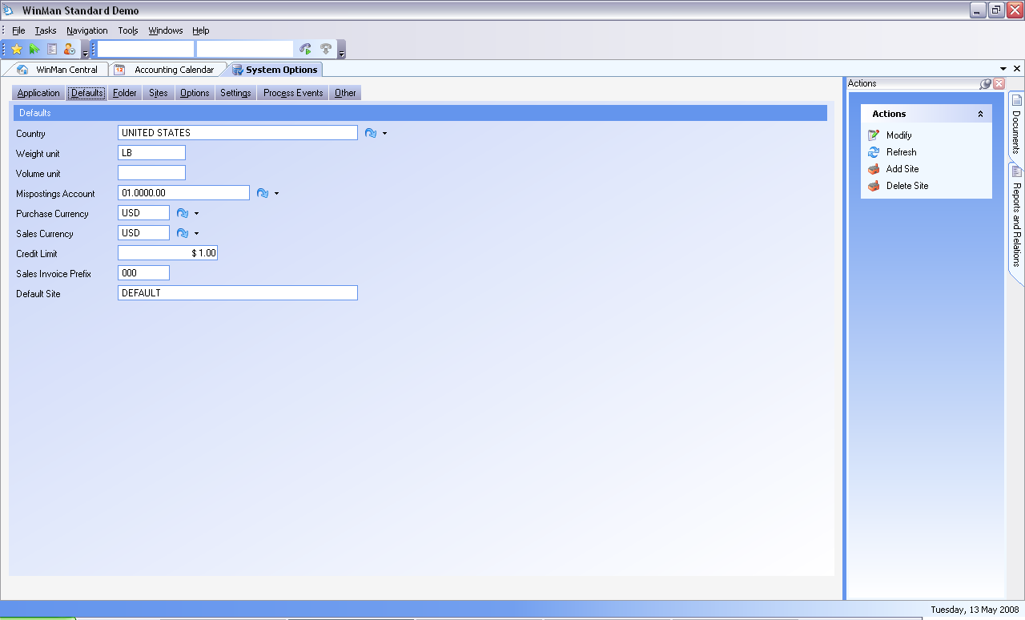

Sites Tab Default Accounts Tab

Default Division – This should be the default division for the site

Default Account Type – This should be the 999999 account.

Default GL Department – This should be the default department for the site. This is the department that all balance sheet account will post to.

Default chart of account – This should be the combination of the 3 above GL fields

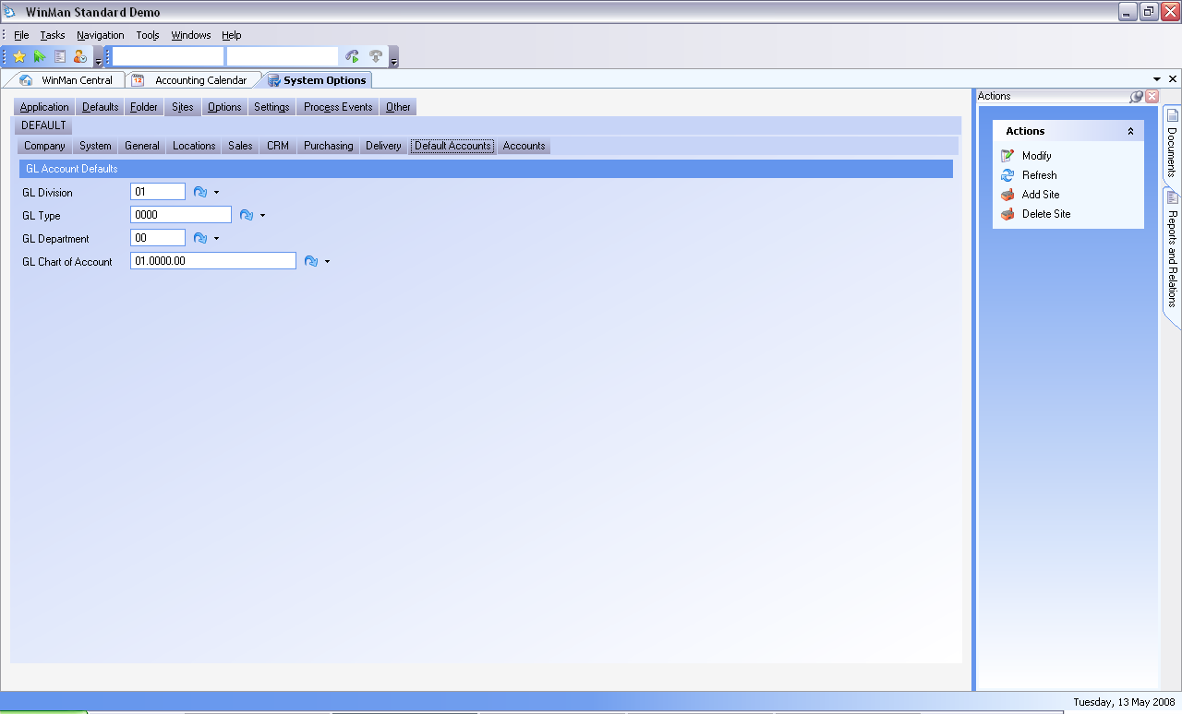
Sites Tab Accounts Tab

Sales – The default sales account when creating a part and used for sales when no price list exists. This is a revenue account.

Cost of Sales – The default cost of sale account. This is a Cost of Sale Account.

GSNI – A suspense account for inventory before it is moved to COGS (see GSNI sub-ledger section for more details). This is a liability account.

Bank – The default account when a new bank is created. This is an asset account.

Labor – The default labor account when a product is created. This is an expense account.

Work in Progress – The default WIP account when a product is created. This is an asset account.

Depreciation – Account for depreciation when using fixed assets module. This is an expense account.

Purchase Free Text – The default account for vendor free text items. This is an expense account.

Inventory – The default inventory account when a product is created. This is an asset account.

Tax – The default tax account for when a new tax code is created. This is a liability account.

GRNI – A suspense account for inventory before the AP invoice is received (see GRNI sub-ledger section for more details). This is a liability account.

Jobs – Default account for where jobs will post to (typically a WIP type account). This is an asset account.

Overheads – The default overhead account when a product is added. This is an expense account.

Variance – Any variances from AP or Manufacturing (if standard cost system). This is an expense account.

NRNI - A suspense account for non-inventory items before the AP invoice is received (see GRNI sub-ledger section for more details). This is a liability account.

SYSTEM SETTING: The default setting in WinMan is to not use NRNI. This can be altered from System Options Options Utilities. Select the option for Use NRNI, set it to “Y” and enable the option. Additionally, the types of items that will post to NRNI can be set using the option NRNI types to post which by default will post all non-inventoried items (set to N,S,F for Free Text, Sundries, Freight). Simply remove the letter for items that should not post to NRNI (ie if only Free Text and Sundries are required use N,S)

Sales Free Text – The default account for customer free text items. This is a revenue account.

Progress Payment – This is the account that early payment invoices will be received against. This is a liability account.

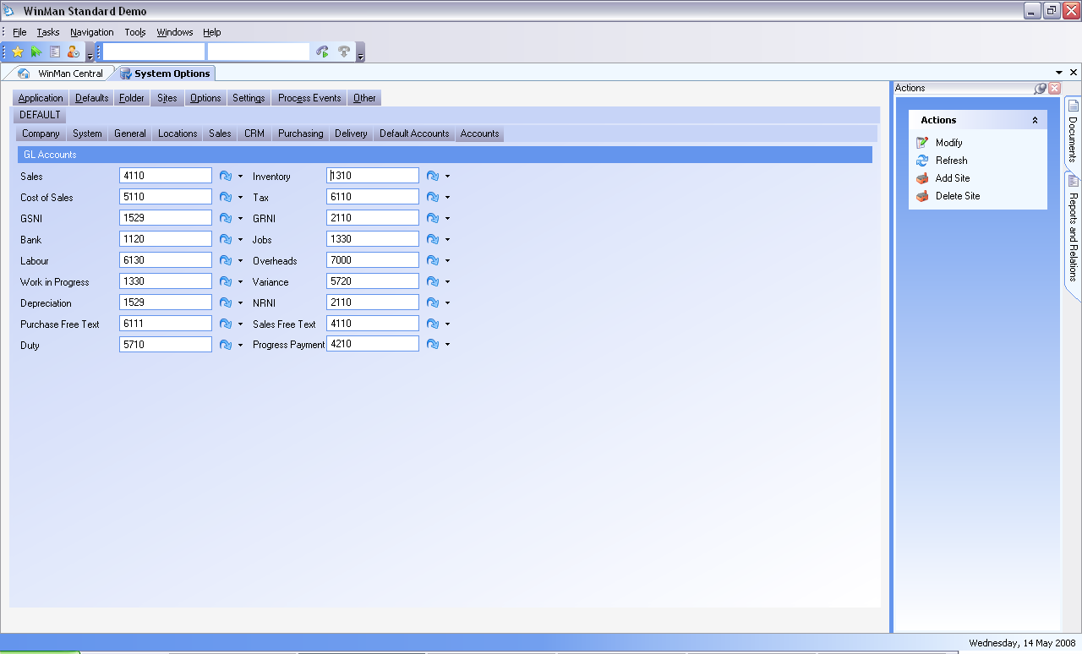

Sites Tab Sales Tab

GL Type – The default GL account (Accounts receivable) when a new customer is added

GL Division – The default GL division when a new customer is added

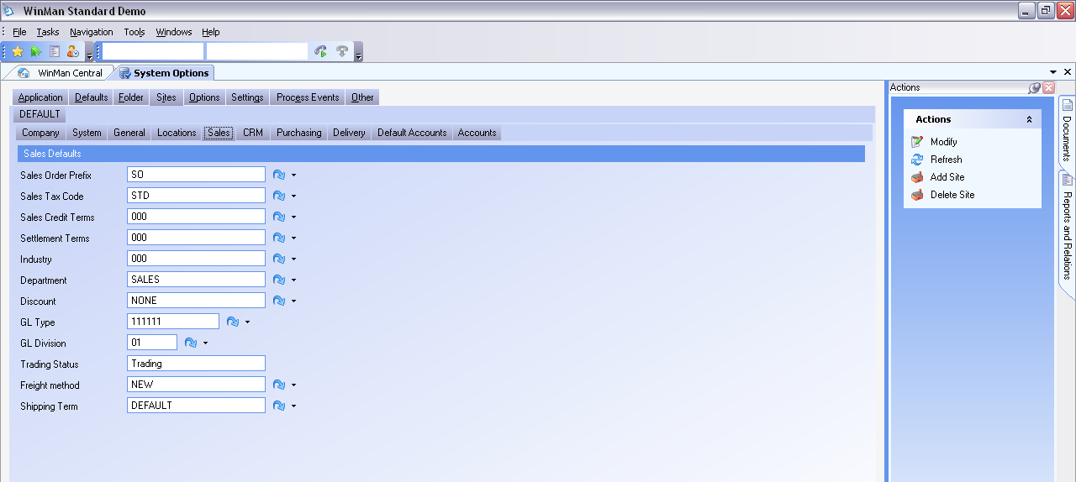

Sites Tab Purchasing Tab

GL Type – The default GL account (Accounts payable) when a new supplier is added

GL Division – The default GL division when a new supplier is added

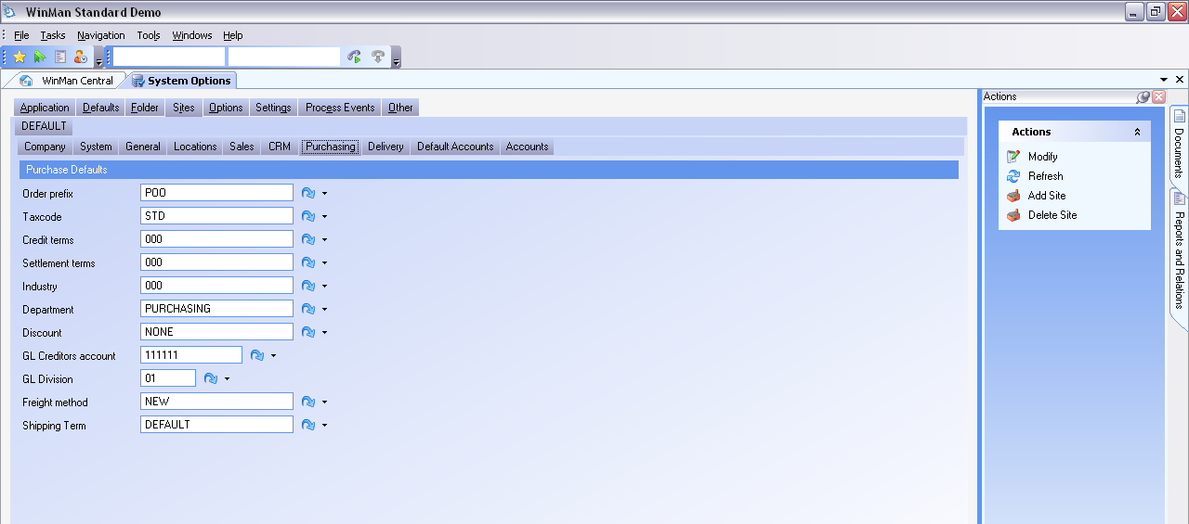
Sub-ledgers

WinMan has 7 sub-ledgers which are used to control specific balance sheet accounts;

- Cash
- Goods Received Not Invoiced (GRNI)
- Goods Shipped Not Invoiced (GSNI)
- Inventory
- WIP
- Account Payable
- Accounts Receivable

The sub-ledgers provide the detail that makes up the account balances on the balance sheet. Sub-ledgers are where cash balances, customer balances, supplier balances, etc are held, and are in real time. The General Ledger, simply takes the detail from the sub-ledger and posts the value.

Accounts Receivable

The Accounts receivable sub-ledger is set-up from the Customers program. Within Customers, on the Accounting tab, there are fields for the division and the account to which Accounts receivable will post for that customer. WinMan then uses the system default department to create the chart of account. There are no limitations as to how many AR accounts can be used.

AR transactions are posted by way of finalized:

- Sales Invoices – Sales Invoices program (Sales Sales Invoices)
- Sales Invoices – Sales Orders program (Sales Sales Orders Process Progress Payments)
- Credit Notes – Sales Invoices program (Sales Sales Invoices)
- Cash Receipts – Cash program (Cash Cash)
- Cash Payments to Customers. (Cash Bank Review Actions Bank Contras)

When reviewing the AR sub-ledger, the Aged Receivables report will provide the detail as to what is making up the AR sub-ledger. The Aged Receivables as of a Date report will allow you to determine the detail for previous dates (typically a month end date) that can provide detail for previous period balances of the AR account(s).

The AR report should match to the GL balance. In cases when it doesn’t, the GL review program should be used to look for non-AR related transactions that are causing the GL to not balance to the sub-ledger.

When using the GL Review program there should only be items that have the following sources;

- “SI” – For Sales Invoices and Credit Notes
- “CS” – For cash receipts (Receipts against invoices and unallocated receipts)
- “CE” – For Bank Contras (payments to customers)

All other transactions will cause the GL to not match the sub-ledger. Corrections should be made by way of a journal entry from the AR account, to the account where the transactions should have posted.
If the difference still exists, compare the Aged Receivables report to the Aged Receivables as of a Date report and find the customer(s) with a difference. Contact WinMan support with the customer(s).

Accounts Payable

The Accounts Payable sub-ledger is set-up from the Suppliers program. Within Suppliers, on the Accounting tab, there are fields for the division and the account to which Accounts Payable will post for that Supplier. The chart of account then uses the system default department to create the chart of account. There are no limitations as to how many AP accounts can be used.

AP transactions are posted by way of finalized;

- Purchase Invoices – Purchase Invoices program (Purchasing Purchase Invoices)
- Credit Notes – Purchase Invoices program (Purchasing Purchase Invoices)
- Cash Payments – Cash program (Cash Cash)
- Cash Receipts from Suppliers – Cash Program (Cash Bank Review Actions Bank Contras)

When reviewing the AP sub-ledger, the Aged Payables report will provide the detail as to what is making up the AP sub-ledger. The Aged Payables as of a Date report will allow you to determine the detail for previous dates (typically a month end date) that can provide detail for previous period balances of the AP account(s).

The AP report should match to the GL balance. In cases when it doesn’t, the GL review program should be used to look for non-AP related transactions that are causing the GL to not balance to the sub-ledger.

When using the GL Review program there should only be items that have the following sources;

- “PI” – For Purchase Invoices and Credit Notes
- “CQ” – For cash payments (Payments against invoices and unallocated receipts)
- “CE” – For Bank Contras (Receipts from suppliers)

All other transactions will cause the GL to not match the sub-ledger. Corrections should be made by way of a journal entry from the AP account, to the account where the transactions should have posted.

If the difference still exists, compare the Aged Payables report to the Aged Payables as of a Date report and find the supplier(s) with a difference. Contact WinMan support with the supplier(s).

Goods Shipped Not Invoiced (GSNI)

Goods Shipped Not Invoiced is a suspense account that holds the inventory value of the items being shipped. This does not include sundries, free text items, or freight items. The GSNI account is found in the system options and is considered an Asset account.

Once a shipment is finalized the GSNI posting will get debited (increased) and will be credited (decreased) when a finalized sales invoice is created for the shipment. While most companies will choose to invoice their customers immediately, there are instances where finalized shipments are not invoiced. When invoices are created immediately, the net effect on GSNI is $0. When invoices are not created immediately, there will be a balance in GSNI until the finalized invoice is created.

The Goods Shipped Not Invoiced report is used to review the detail that makes up the sub-ledger balance. This balance should match the value in the GL for the GSNI account. If any differences exist, the GL Review program should be used to review the GSNI account.

When using the GL Review program there should only be items that have the following sources;

- “SG” – For Sales Invoices
- “SH” – For Shipments

All other transactions will cause the GL to not match the sub-ledger. Corrections should be made by way of a journal entry from the GSNI account, to the account where the transactions should have posted.

If the difference still exists, contact WinMan support.

NOTE: WinMan handles GSNI transactions and no manual entries are required
Goods Received Not Invoiced (GRNI)

Goods Received Not Invoiced is a suspense account that holds the inventory value of the items being received into inventory and don’t have an invoice. This is for inventory items only, and does not include the value of free text, sundries, or freight items. The GRNI account is found in the system options and is considered a Liability account.

Once a Goods Receipt is finalized, the inventory account will be credited, and the GRNI account will be debited. GRNI is basically holding the value of the AP invoice, until the invoice is actually entered. Once a finalized Purchase Invoice has been entered into WinMan for the Receipt, GRNI will be credited.

The Goods Received Not Invoiced report is used to review the detail that makes up the sub-ledger balance. This balance should match the value in the GL for the GRNI account. If any differences exist, the GL Review program should be used to review the GRNI account.

When using the GL Review program there should only be items that have the following sources;

- “PD” – For Purchase Invoices
- “PG” – For Receipts
- “PW” – For variances between receipt value and invoice value

All other transactions will cause the GL to not match the sub-ledger. Corrections should be made by way of a journal entry from the GSNI account, to the account where the transactions should have posted.

If the difference still exists, compare the Goods Received Not Invoiced report to the Goods Received Not Invoiced as of a Date report and find the receipts(s) with a difference. Contact WinMan support with the receipt(s).

TIP: WinMan handles GRNI transactions and no manual entries are required

Cash

Cash is the value in local currency for each bank. Within the set-up for each bank, is a GL account. There should be one GL account for each bank which will allow balances to be viewed on the balance sheet.

Cash transactions are posted by way of finalized;

- Cash Receipts – Cash program (Cash Cash)
- Cash Payments – Cash program (Cash Cash)
- Cash GL entries – Cash Program (Cash Cash)
- Bank Transfers – Bank Review Program (Cash Bank Review Actions Transfers)

When reviewing the Cash sub-ledger, the Cash Book report will provide the detail as to what is making up the Cash sub-ledger. Use the date range to review a single period, or a start date prior to your WinMan go-live date and the current date to review the current balance.

The Cash Book – Local currency report should match to the GL balance. In cases when it doesn’t, the GL review program should be used to look for non-Cash related transactions that are causing the GL to not balance to the sub-ledger.

When using the GL Review program there should only be items that have the following sources;

- “CR” – For Cash Receipts
- “CP” – For Cash Payments
- “CG” – For Cash GL
- “CT” – For Bank Transfers

All other transactions will cause the GL to not match the sub-ledger. Corrections should be made by way of a journal entry from the Cash account, to the account where the transactions should have posted.

If the difference still exists, compare the Cash Book report to the Balance on the Balance sheet and determine which period is causing the difference. Contact WinMan support with the period(s).

Inventory

Inventory is the value of goods, which can be raw materials and/or finished goods. Depending on how inventory is needed to be viewed, you can have as few as 1 inventory account to as many as you need. There are 2 common approaches 1 is to have 1 inventory account and the other is to have 3 (raw material, finished goods and WIP). WIP in this case is not Work in progress from work orders, but rather finished sub-assemblies that are waiting to be used in a finished good.

Inventory transactions are posted by way of finalized;

- Goods Receipts – Goods Receipts program (Purchasing Goods Receipts)
- Shipments – Shipments program (Sales Shipments)
- Finished Work Orders – Manufacturing Orders program (Manufacturing Manufacturing Orders)
- Issues to WIP – Manufacturing Orders program (Manufacturing Manufacturing Orders)
- Stock Adjustments – Inventory Review program (Inventory Inventory Review)
- Stock Movements – Inventory Review program (Inventory Inventory Review)

When reviewing the Inventory sub-ledger, the Inventory report will provide the detail as to what is making up the Inventory sub-ledger by account. The Inventory as of a Date report will allow you to determine the detail for previous dates (typically a month end date) that can provide detail for previous period balances of the Inventory account(s).

The Inventory report should match to the GL balance. In cases when it doesn’t, the GL review program should be used to look for non-AP related transactions that are causing the GL to not balance to the sub-ledger.

When using the GL Review program there should only be items that have the following sources;

- “PR” – For Goods Receipts
- “SS” – For Shipments
- “IF” – For Finishing Work Orders
- “IB” – For Issues to WIP
- “IM” – For Stock Movements and Stock Adjustments

All other transactions will cause the GL to not match the sub-ledger. Corrections should be made by way of a journal entry from the Inventory account, to the account where the transactions should have posted.

If the difference still exists, compare the Inventory report to the Inventory as of a Date report and find the part(s) with a difference. Contact WinMan support with the part(s).

WIP

WIP is the value of components/sub-assemblies that are issued to manufacturing orders. Items are taken from Inventory and moved to WIP until the manufacturing order is completed.

WIP transactions are posted by way of;

- Finished Work Orders – Manufacturing Orders program (Manufacturing Manufacturing Orders)
- Issues to WIP – Manufacturing Orders program (Manufacturing Manufacturing Orders)

When reviewing the WIP sub-ledger, the WIP – General Ledger report will provide the detail as to what is making up the WIP account. The WIP – General Ledger report allows you to determine the detail for previous dates (typically a month end date) that can provide detail for previous period balances of the WIP account.

The WIP – General Ledger report should match to the GL balance. In cases when it doesn’t, the GL review program should be used to look for non-WIP related transactions that are causing the GL to not balance to the sub-ledger.

When using the GL Review program there should only be items that have the following sources;

- “WW” – For Items issued to WIP
- “WF” – For Items finished from WIP
- “WV” – For variances when items are finished to WIP

All other transactions will cause the GL to not match the sub-ledger. Corrections should be made by way of a journal entry from the Inventory account, to the account where the transactions should have posted.

If the difference still exists, compare the WIP – General Ledger report to the Balance on the Balance sheet and determine which period is causing the difference. Contact WinMan support with the period(s).

Financial Statement Set-up

Balance Sheet

The accounts that are used on the balance sheet are determined by way of the GL classification. Accounts are linked to a GL classification by way of the GL account Types program (Accounting Standing Data GL account Types). The GL classification (Accounting Standing Data GL Classifications) determines if the Classification belongs on the Balance sheet or the Profit and Loss. The sequence number of the classification determines the position on the balance sheet. The sequence number must be a 3 digit number and;

- Assets must start with 1 eg 100, or 110
- Liabilities must start with 2 eg 200 or 285
- Equity must start with 3 eg 300 or 305

In addition to GL classifications, there is an additional grouping used to group classifications called GL categories. GL categories are used to facilitate sub-totals for classifications. Categories use the smallest sequence number of the related GL classifications

Eg
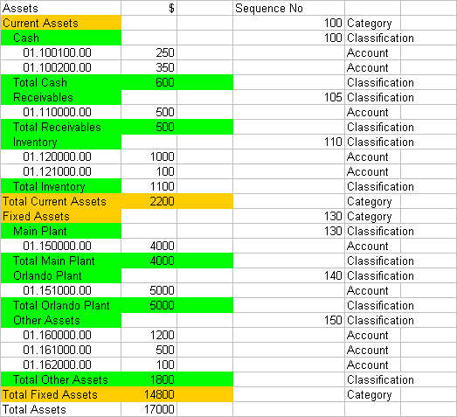

Balance sheet reports found in WinMan include;
Balance sheet for a single period
Balance sheet by Period
Balance sheet by Period accumulated totals
Balance Sheet by Period vs Last Year
Balance Sheet by Period vs Last Year accumulated totals
Balance Sheet single period vs Last Year

Income Statement

The accounts that are used on the balance sheet are determined by way of the GL classification. Accounts are linked to a GL classification by way of the GL account Types program (Accounting Standing Data GL account Types). The GL classification (Accounting Standing Data GL Classifications) determines if the Classification belongs on the Balance sheet or the Profit and Loss. The sequence number of the classification determines the position on the balance sheet. The sequence number must be a 3 digit number and;

- Revenue must start with 4 eg 400, or 410
- Cost of Sales must start with 5 eg 500 or 585
- Selling, General and Admin must start with 6 OR 7 eg 600 or 705
- Other Income/Expense must start with 8 eg 800 or 850
- Tax must start with 9 eg 900 903

In addition to GL classifications, there is an additional grouping used to group classifications called GL categories. GL categories are used to facilitate sub-totals for classifications. Categories use the smallest sequence number of the related GL classifications. GL categories are typically used more with the balance sheet. If GL categories are not required on the income statement, use the following categories to group accounts;

NET SALES for all revenue accounts
COST OF SALES for all cost of sales accounts
SG&A for all selling, general and admin accounts
OTHER INCOME/EXPENSE for all other income and expense accounts
TAX PREVISIONS/DIVIDENDS/DISTRIBUTIONS for all tax accounts

WinMan will not print out the above GL categories on the income statement.

Income Statement report found in WinMan Include;

Income Statement
Income Statement – Budget
Income Statement – Budget by Quarter
Income Statement – Comparative (Comparisons to previous period(s) or budget(s)
Income Statement by Period
Income Statement by Period Accumulated Totals
Income Statement by Quarter

Additionally, the Departmental Analysis report can be used for SG&A accounts only. If GL departments are used, this report can analyze departmental expenses in relation to budget or previous periods.

Statement of Cash Flow (Optional)

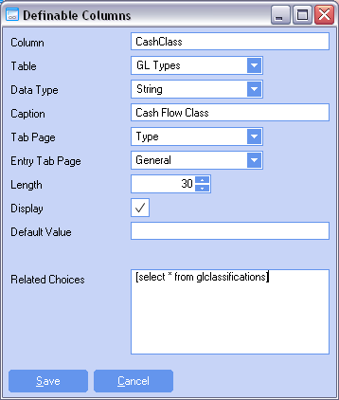
If a statement of cash flow is required, some additional set-up is required. An definable spare field in the GL Account Types program will need to be set up exactly as shown in figure 1.

GL classifications should be created to group accounts like the balance sheet and income statement. Accounts, though, do not have to have the same classifications as the classes used on the balance sheet or income statement. When creating the classes, the type will not matter if it is balance sheet or income statement. The sequence number, much like the balance sheet and income statement, will be used to group classifications and determine the order that the class will appear on the statement of cash flow.

Example

 |  |  |  |  | Sequence |  | Example Values
Net Income (automatically calculated) |  |  |  |  |  |  | 1000
Adjustments to Net Cash |  |  |  | GL Category
 | Depreciation |  |  | GL Class | 100 |  | 75
 | Asset Disposal |  |  | GL Class | 105 |  | 125
Total Adjustments to Net Cash |  |  |  |  |  |  | 200
Changes to Operating Assets |  |  |  | GL Category
 | Receivables |  |  | GL Class | 200 |  | 300
 | Inventory |  |  | GL Class | 205 |  | 200
 | Payables |  |  | GL Class | 210 |  | -250
Total Changes to Operating Assets |  |  |  |  |  |  | 350
NET CASH |  |  |  |  |  |  | 1550

Accounting Transactions – Sales

Sales Order

The only accounting transactions that take place from a sales order are Progress Payment Invoices that are created. Progress Payment Invoices are created through auto-invoicing if a date is specified, or when the sales order is firmed, if on-order is specified.

A finalized progress payment invoice will have an impact on the GL as AR will be debited and Deferred Revenue will be credited. The value of the invoice will be defined by the progress payment (percentage of order, or fixed value)

 | Debit | Credit
Progress Payment Invoice
AR | 500
Deferred Revenue |  | 500

The AR account is calculated by using the division and account from the customer, and the system default GL department.

The Deferred Revenue account is created using the division of the customer. If the system profile to use the division of the sales order prefix is enabled, this will override the division from the customer. The account will be the progress payment account found in the system default and the GL department is the system default GL department.

TIP: Deferred Revenue is typically either classified as a Liability or a Revenue account.

While no accounting function takes place, each item entered on a sales order has a GL account associated with it for revenue purposes. This GL account is used when the item is invoiced. The GL account is calculated based on the type of item.

Division – By default the division comes from the customer. For products only, a sales division can be entered on a product basis, in the products program. This will override the division from the customer.

SYSTEM OPTION: The division can come from the sales order prefix instead of the customer. Use the Sales Orders system option Use the GL division from the sales order prefix. Enable the option and set the value to Y to use the division from the prefix. Note that if a division from products is used, this will over-ride the prefix division in the same way it over-rides the customer division

Account for Products – If price lists are used, the product pricing record (Sales Standing Data Prices) for the price type of the sales line item will be used. If price types are not used, the default sales account in products is used.

Account for Sundries – The GL revenue account for sundries is used

Account for Freight – The GL revenue account for freight methods is used

Department – The default system GL department is used with all transactions

TIP: Free text items allow a user to pick the entire GL chart of account. A default account can be established on a per customer basis to aid in account selection.

Shipment

A shipment can be created either by;
- The shipping program and selecting New Shipment
- The sales order program and selecting Ship

A finalized shipment will have an impact on the GL as Goods Shipped Not Invoiced (GSNI) will be debited and Inventory will be credited. The value of the transaction will be the total value of the inventory being shipped.

 | Debit | Credit
Goods Shipped to Customer
GSNI | 500
Inventory |  | 500

The GSNI account is calculated by using the division of the inventory item being shipped, the default GSNI account, and the system default GL department.

The inventory account is the division of the location of the inventory, the inventory account from products and the system default GL department.

Create an Invoice from a shipment

An invoice from a shipment can be created by;

- Selecting the action Invoice this Shipment from the Shipments program
- Running the Auto-Invoice utility
- Creating an Invoice in Sales Invoices and adding Shipped Items

A finalized Invoice created from a shipment will credit the Revenue and GSNI accounts and debit the AR and Cost of Sales accounts.

 | Debit | Credit
Invoice a Shipment
GSNI |  | 500
COS | 500
AR | 1000
Revenue |  | 1000

The GSNI account is calculated by using the division of the inventory item being shipped, the default GSNI account, and the system default GL department.

The Cost of Sale account uses the division from the revenue account for the invoice line item. If the revenue account has a cost of sales override (in GL account types), the cost of sales override will be used. If, however, there is no cost of sales override, the default Cost of Sales account (System Set-Up) will be used. The system default department is used for the GL department.

The AR account uses the division and control account for the customer on the invoice. The department used, is the system default department.

Revenue accounts are determined from the sales order. In cases where there is no sales order line to reference(manual invoices, freight items), the revenue accounts are calculated the same way as from a sales order.

Creating a finalized invoice will show on the customer account in Customer Review. The amount owing on an invoice can be determined by reviewing the Value Outstanding field on the invoice.

In cases when a manual invoice is created and no products are shipped, COS and GSNI will always have a value of $0
Create a Credit

Credits can be created by;

- Sales Invoices program and selecting New Credit
- RMA program and selecting Credit all or Credit ITEM

A finalized credit will credit the AR account and debit the credit memo account

Debit Credit
Create a credit
AR 1000
Credit memo Account 1000

The AR account uses the division and control account for the customer on the credit. The department used, is the system default department.

If the credit is related to an existing invoice, the debit account will be the revenue account from the sales invoice line item. If the credit is not related to an invoice, the debit account will be picked manually by the user.

If the credit is created from the RMA module, the debit account will use the division and sales type account from products and the GL department for the default site.

Accounting Transactions – Purchasing

Purchase Orders

No accounting transactions take place with a purchase order. GL accounts act as default inventory account, however, accounts are calculated at time of goods receipt based on the actual location items are received to. Non-inventoried item’s accounts are used to expense when using NRNI, or if NRNI is not used the accounts are used as defaults for the voucher

Goods Receipts

- A goods receipt can be created via the Goods Receipt program.

A finalized Goods Receipt for inventoried items will credit the GRNI accounts and debit the Inventory accounts. If non-inventoried items are to be accrued, a finalized Goods Receipt will credit the NRNI account and debit the expense account.

Debit Credit
Goods Receipt (Inventory)
GRNI 900
Overhead 40
Labor 40
Duty 20
Inventory 1000

Debit Credit
Goods Receipt (Non-Inventory)
NRNI 1000
Expense 1000

SYSTEM SETTING: The division that will be used for all transactions, with the exception of inventory, will come from the system setting in Goods Receiving called Process goods receipts to the GL to either L=Location Division, C=Control division or S=Supplier division. The division can be set to;
-S for division from the supplier master
-L for the division from the inventory location
-C for the default division for the site

TIP: WinMan recommends using the division from the Supplier Master.

The division used for the GRNI account will be the Goods receiving division as defined above. The GRNI account will come from the site’s default GRNI account found in system set-up. The site default department will be used.

The Inventory division will be the division found in the location where the item was received to. The inventory account is the inventory account found in products. The site default department will be used.

The division used for the overhead account will be the Goods receiving division as defined above. The account used for the overhead recovery is the overhead account found in products. The GL department is the site default GL department.

The division used for the labor account will be the Goods receiving division as defined above. The account used for the labor recovery is the labor account found in products. The GL department is the site default GL department.

The division used for the Duty account will be the Goods receiving division as defined above. The account used for duty is the duty account found in products. If no account is given, the site default duty account will be used. The GL department is the site default GL department.

The division used for the NRNI account will be the Goods receiving division as defined above. The NRNI account will come from the site’s default NRNI account found in system set-up. The default department will be used.

The expense account will be the expense account found on the purchase order line item.

TIP: When receiving into a location with availability of Consignment, no accounting transactions will occur until the item is moved to a non-consignment location

TIP: When receiving into a location with availability of Bonded, the receipt will generate all accounting transactions with the exception duty. Duty will be added to the inventory once the item is moved to a non-bonded location

TIP: When receiving a sub-contract PO, GRNI will be credited and WIP will be generated. The GRNI account is created as above. The WIP account uses the default division and department from the default site. The WIP account type is in the WIP account type from the product being manufactured on the manufacturing order

Matching the Voucher to the Goods

A voucher for a receipt can be created by;

- Creating a voucher in Purchase Invoices and adding Received Items

A finalized Invoice created from a Goods Receipt will credit the AP account and debit the GRNI and/or Variance accounts.

 | Debit | Credit
Invoice a Shipment
GRNI | 500
Variance | 50
AP |  | 550

The GRNI division is determined by the Goods Receipt Default division system option. The division can be set to S for division from the supplier master, L for the division from the inventory location, or C for the default division for the site. WinMan recommends using the division from the Supplier Master. The GRNI account will come from the site’s default GRNI account found in system set-up. The default department will be used.

The variance account is the variance account found in system set-up. The variance division is the default division. The variance department is the default department.

The AP account uses the division and control account for the supplier on the voucher. The department used, is the system default department.

Creating a finalized invoice will show on the supplier account in Supplier Review. The amount owing on an invoice can be determined by reviewing the Value Outstanding field on the invoice.

Accounting Transactions – Cash

Cash Received

A Cash receipt can be created by;

- Adding an unallocated item to a cash receipt in the cash program
- Adding an item (invoice) to a cash receipt in the cash program
- Adding a credit card receipt in the sales order program(if credit card integration is used)

A finalized cash receipt will debit cash and credit the AR account, the write-off account the exchange gain/loss and the settlement discount account.

 | Debit | Credit
Receive Cash
Cash | 500
AR |  | 450
Write off |  | 15
Settlement Discount |  | 15
Exchange Difference |  | 20

The entire cash account comes from the bank selected for the cash receipt

The AR account uses the division and control account from the customer. The department used, is the system default department.

The write off code uses the account type for the write off code selected. The default site GL division and GL department are used to create a default account. The user can then select an GL chart of accounts that exist that use the Account type found in the write off code.

The exchange difference code uses the account type for the exchange difference code selected. The default site GL division and GL department are used to create a default account. The user can then select an GL chart of accounts that exist that use the Account type found in the write off code.

The settlement discount account will use the default site GL division and GL department. The account will be the default site Cost Of Sale account.

SYSTEM SETTING: The account for settlement discounts can be changed to a different account in the system options. Use system optionsGeneral Accounts for settlement discount to post to.
Note: The entry for this system setting needs to be GLaccounttypes.Glaccounttype

Cash Payment

A Cash payment can be created by;

- Creating a payment run in the Payment Runs program
- Creating a payment in the Cash program

A finalized cash payment will debit AP and credit the cash account, the exchange gain/loss and the settlement discount account.

 | Debit | Credit
Pay Cash
Cash |  | 500
AR | 450
Exchange Difference | 30
Settlement Discount | 20
The entire cash account comes from the bank selected for the cash payment

The AP account uses the division and control account from the supplier. The department used, is the system default department.

The exchange difference code uses the account type for the exchange difference code selected. The default site GL division and GL department are used to create a default account. The user can then select an GL chart of accounts that exist that use the Account type found in the write off code.

The settlement discount account will use the default site GL division and GL department. The account will be the default site Cost Of Sale account.

SYSTEM SETTING: The settlement discount can be changed to a different account in the system option. Use system optionsGeneral Accounts for settlement discount to post to.
Note: The entry for this system setting needs to be GLaccounttypes.Glaccounttype

Accounting Transactions – Inventory

Manufacturing Orders

Manufacturing Order transactions can be creating by;

- Issuing and Finishing items in Manufacturing Orders
- Processed Kanbans in Kanban Manufacturing

Issuing components is done automatically when using Kanban Manufacturing. When using Manufacturing Orders, the user can right click on a WIP line to issue individual lines, or use the process action to mass issue.
Issuing components to a work order will debit the WIP account and credit the inventory account.

Debit Credit
Issue Items to a Manufacturing Order
WIP 1000
Inventory 1000

The WIP account is created with the default site GL division and the default site GL department. The WIP account is from the product master for each component.

The Inventory account will be the account from where the inventory is moved from. The account is created from the division of the location of the item, the inventory account of the component from products and the site default GL department.

Adding direct (or actual) labor or overhead to a manufacturing order can be done using the Add Cost action in manufacturing orders or using the Labor Recordings or Time Sheet programs. Actual values will post to the GL once they have been added to the Manufacturing Order

Debit Credit
Issue labor/overhead to a Manufacturing Order
WIP 400
Labor 200
Overhead 200

The WIP account is created using the default division and default department of the default site. The WIP account is from products for the product being manufactured.

The Labor account is created using the default division and default department of the default site. The Labor account is from products for the product being manufactured.
If the labor is being added from a process, the labor account from the process will override the account from products.

The Overhead account is created using the default division and default department of the default site. The Overhead account is from products for the product being manufactured.
If the overhead is being added from a process, the labor account from the process will override the account from products.

Finishing items on a Manufacturing Order

Finishing a manufacturing order can be done in the Manufacturing Orders program using the Finish Items Action. Orders can also be finished in the Goods Receiving program for sub-contract manufacturing orders. Orders can be finished from the Kanban Manufacturing program when a batch is processed.

Debit Credit
Finish A Manufacturing Order
WIP 500
Labor 200
Overhead 200
Sundry 40
Material Variance 20
Labor Variance 20
Overhead Variance 20

The WIP account is created by using the default GL division and GL department for the default site. The WIP account is the WIP account found in products for the item being manufactured.

The Labor account is created by using the default GL division and GL department for the default site. The Labor account is the Labor account found in products for the item being manufactured. In the case of labor being added from a process, the labor account from the process will override the labor account from products.

The Overhead account is created by using the default GL division and GL department for the default site. The Overhead account is the Overhead account found in products for the item being manufactured. In the case of overhead being added from a process, the overhead account from the process will override the overhead account from products.

Standard Cost System

The Material Variance account is created by using the default GL division and GL department for the default site. The Material Variance account is the Material Variance account found in products for the item being manufactured. If no account is found in products, the system default variance account will be used. The variance value will be the difference in material value issued to the work order and the standard material value of the item.

The Labor Variance account is created by using the default GL division and GL department for the default site. The Labor Variance account is the Labor Variance account found in products for the item being manufactured. If no account is found in products, the system default variance account will be used. The variance value will be the difference in labor value issued to the work order and the standard labor value of the item.

The Overhead Variance account is created by using the default GL division and GL department for the default site. The Overhead Variance account is the Overhead Variance account found in products for the item being manufactured. If no account is found in products, the system default variance account will be used. The variance value will be the difference in overhead value issued to the work order and the standard overhead value of the item.

Stock Movements

Stock movements can be completed in the inventory review screen by;

Right clicking on a batch of inventory and Changing Location
ActionsToolsInventory Maintenance Bulk Location Transfer

A stock movement will credit the inventory location being moved from and debit the location being moved to. The 2 exceptions being moves from locations with availability of Bonded or Consignment (See below)

Debit Credit
Move Item in Inventory
Inventory 400
Inventory 400

Credited Inventory account is the account of the line item being moved

Debited Inventory account is the division of the location, the inventory account of the item from products, and the site default GL department.

Move item received into location with availability of Consignment

A move from a Consignment location will generate the receiving transactions. Specifically, inventory and GRNI accounting transactions will occur. See Section on Receiving for more detail

Move item received into location with availability of Bonded

A move from a bonded location will generate any duty transactions that have not yet occurred. See Section on Receiving for more detail

Inventory Adjustments

Inventory adjustments are completed in the Inventory Review program. Stock increases are completed by selecting the increase stock action. Stock decreases are completed by selecting the batch to decrease and either decreasing the quantity or decreasing the value.

When a stock adjustment (increase) is completed it will Debit the inventory account and credit the adjustment account.

Debit Credit
Adjust Inventory (Increase)
Adjustment Account 200
Inventory 200

The inventory account is created using the GL division from the location of the item, the inventory account of the item, and the site default GL department.

The adjustment account uses the account type for the Inventory reason code selected by the user. If more than one GL chart of Account exists for the account type, the user must pick from a drop down list of all available GL chart of accounts. If only 1 GL chart of account exists, this will be used as the account and the user will not have to enter a GL account code.

When a stock adjustment (decrease) is completed it will Credit the inventory account and debit the adjustment account.

Debit Credit
Adjust Inventory (Increase)
Adjustment Account 200
Inventory 200

The inventory account is the inventory account from the batch that they user selected to adjust.

The adjustment account uses the account type for the Inventory reason code selected by the user. If more than one GL chart of Account exists for the account type, the user must pick from a drop down list of all available GL chart of accounts. If only 1 GL chart of account exists, this will be used as the account and the user will not have to enter a GL account code.
Consumable Materials

Consumable materials items will be expensed to the GL after the number of days
specified within the product classification.

When a consumable material is expensed it will Credit the inventory account and debit the adjustment account.

Debit Credit
Consume Materials
Adjustment Account 200
Inventory 200

The inventory account is the inventory account that the consumable inventory is found in.

The adjustment account is the default site Default GL division and GL department. The adjustment account will be the account related.

Note: As this is an automatic transaction, if the GL chart of account that is compiled does not exist in the GL chart of account, the consumable material will post to the system default account.

Fixed Assets

Fixed assets are managed in the fixed asset module. The module uses straight line depreciation to depreciate an asset.

Depreciating an asset will credit the asset account and debit the depreciation account.

Debit Credit
Depreciate an Asset
Depreciation Account 200
Asset Account 200

The asset account is the account linked the Fixed Asset Type for the Fixed Asset ID.

The depreciation account is created using the division and department of the Asset account and the depreciation account from System set-up.

Closing Periods

The WinMan accounting calendar consists of years and within the year are periods. There is no requirement in WinMan to close a period. However there are system settings that can be used to control and limit postings to previous periods. There is also a system setting that can be used to over-ride the setting for certain users to be able to use dates that have been closed or are in previous periods.

Prevent Postings to Previous Periods.

This will not allow users to select a date from a previous period and no manual intervention is required. For example, if fiscal periods match calendar periods, once the first of the month happens, a user can no longer select any previous months as the transaction date.

SYSTEM OPTION: In the system settings, under General, there is an option to Allow posting to previous periods. Set this to N to activate the setting.

SYSTEM OPTION: In the system settings, under Utilities, there is an option to Only close previous periods after this amount of days has passed. Enable the option and set the value to the number days into the new period should pass before closing the previous period.

Prevent Postings to Closed Periods

This will not allow users to select a date from a period that has been closed. Closing a period is typically done manually once the month end procedures have been completed. A utility in the Utilities module should be set up to close periods and run manually when required.

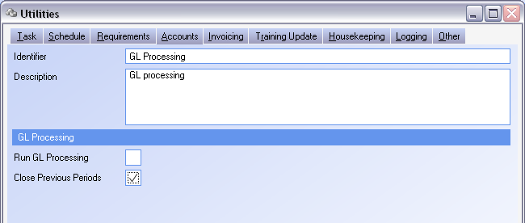

SYSTEM SETTING: In the system settings, under General, there is an option to Allow posting to closed periods. Set this to N to activate the setting.

Closing a Year

Closing the year is a required function in WinMan. When a year is closed, the P&L accounts will bring net income forward to a Profit and Loss account. The Balance sheet accounts will bring their totals forward to the new year. The Year End Close action can be found in the GL Review module, and accessed using the Tools action.

TIP: The Profit and Loss account is typically the Retained Earnings account

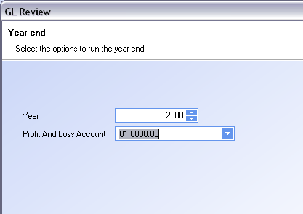
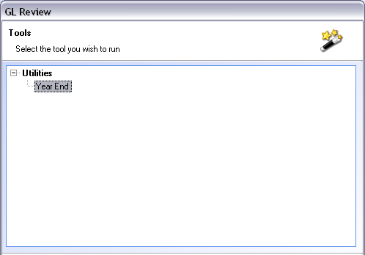

Prevent Postings to Previous Years.

This will not allow users to select a date from a previous year and no manual intervention is required. For example, once the first of the new year happens, a user can no longer select any dates from the previous year(s) as the transaction date.

SYSTEM OPTION: In the system settings, under General, there is an option to Allow posting to previous years. Set this to Y to activate the setting.

Over-Ride system settings to post previous transactions

By default, a user who has Admin for a program has the authority to back-date a transaction to a previous or closed period regardless of the system options mentioned above. This can be useful for entering any transactions to a previous period without having to switch a system setting. This can be especially useful if you select the system option to not allow postings to previous periods, but AP invoices come in on the first of a period and need to be entered in the previous period.

SYSTEM SETTING: In the system settings, under GENERAL, there is an option for Level Required to override accounting date settings. Options include Admin, Full, Add, Modify, View and None. It is recommended that this remain at Admin.

GL Postings in WinMan

All transactions completed in WinMan will post to the GL when GL processing runs. The only exception to this is when a journal entry is made, which will post to the GL in real time.

GL processing can be found in the Utilities module and is typically run automatically on a daily basis.

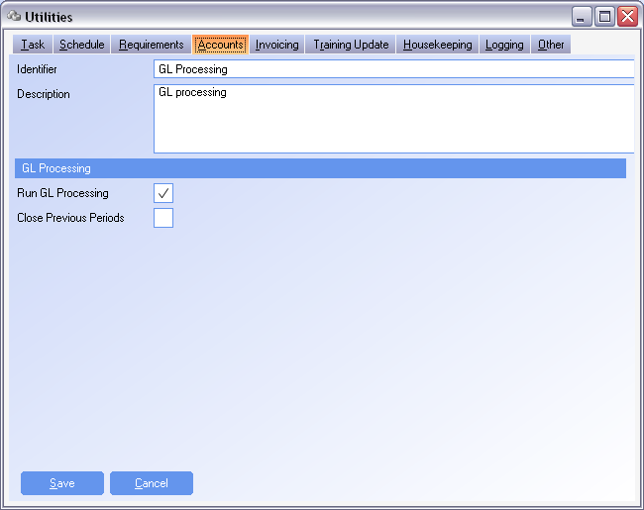

Depending on the number of transactions that take place, accounting transactions can be posted as a batch or as individual transactions. It is recommended that if there is low a high volume of transactions, that this should remain the same. However, for low volume of transactions it makes sense to post in detail. Posting in detail with a high volume of transactions will create many GL records and slow the generation of GL reports.

SYSTEM SETTING: In the system settings, under GL Review, there is an option for Cash – Batch Post GL entries. Set this to N and enable the setting if detailed cash postings are required.

SYSTEM SETTING: In the system settings, under GL Review, there is an option for Default – Batch Post GL entries. Set this to N and enable the setting if detailed postings for all transactions are required.

SYSTEM SETTING: In the system settings, under GL Review, there is an option for Goods Receipts – Batch Post GL entries. Set this to N and enable the setting if detailed goods receiving postings are required.

SYSTEM SETTING: In the system settings, under GL Review, there is an option for Inventory – Batch Post GL entries. Set this to N and enable the setting if detailed inventory postings are required.

SYSTEM SETTING: In the system settings, under GL Review, there is an option for Jobs – Batch Post GL entries. Set this to N and enable the setting if detailed jobs postings are required.

SYSTEM SETTING: In the system settings, under GL Review, there is an option for Purchase Invoices – Batch Post GL entries. Set this to N and enable the setting if detailed purchase invoice postings are required.

SYSTEM SETTING: In the system settings, under GL Review, there is an option for Sales Invoices – Batch Post GL entries. Set this to N and enable the setting if detailed sales invoice postings are required.

SYSTEM SETTING: In the system settings, under GL Review, there is an option for Shipments – Batch Post GL entries. Set this to N and enable the setting if detailed shipping postings are required.

SYSTEM SETTING: In the system settings, under GL Review, there is an option for Work in Progress – Batch Post GL entries. Set this to N and enable the setting if detailed work in progress postings are required.

SYSTEM SETTING: In the system settings, under Utilities, there is an option for Posts zero value items to GRNI if posting by item. When using detailed postings, this will post a $0 GL record for the GRNI transaction if enabled and set to a value of Y. In batch processing, the transaction is automatically included in the batch at $0.

