TTW INC
WinMan
User Security
WinMan 7.0

TTW
5/1/2008

Contents
Overview 3
Programs Module 4
Security Profiles module 6
Users 7

Overview

It is possible to allocate security permissions in WinMan to allow individual users to access as little or as much of the system as they require to carry out their day to day tasks.
In addition users can be allowed access to view only, add, modify or have full access to a particular area.

The process of setting user security is an additive one, i.e. you include the screens that you want a user to see rather than removing the screens that you don’t want them to see

Before embarking on this process you should draw up a matrix table with Users vs Programs and identify the rights required for each individual user for each particular program.
In general we would recommend that only an administrator is able to set up any standing data or undertake any of the administration tasks.

Programs Module

The security area defines which of the WinMan activities are grouped together for ease of set up and maintenance.
A particular WinMan program can only be in one security area. When you require different users to have different access rights to the same module then those modules must be in unique areas.
The navigation tab of the Programs module displays all the WinMan modules and the folders that they can be found in. The navigation tab is used to construct the Navigation menu found in the WinMan menu. Programs can be moved to different locations, however, it should be noted that WinMan documentation references module locations as found in the original setup.

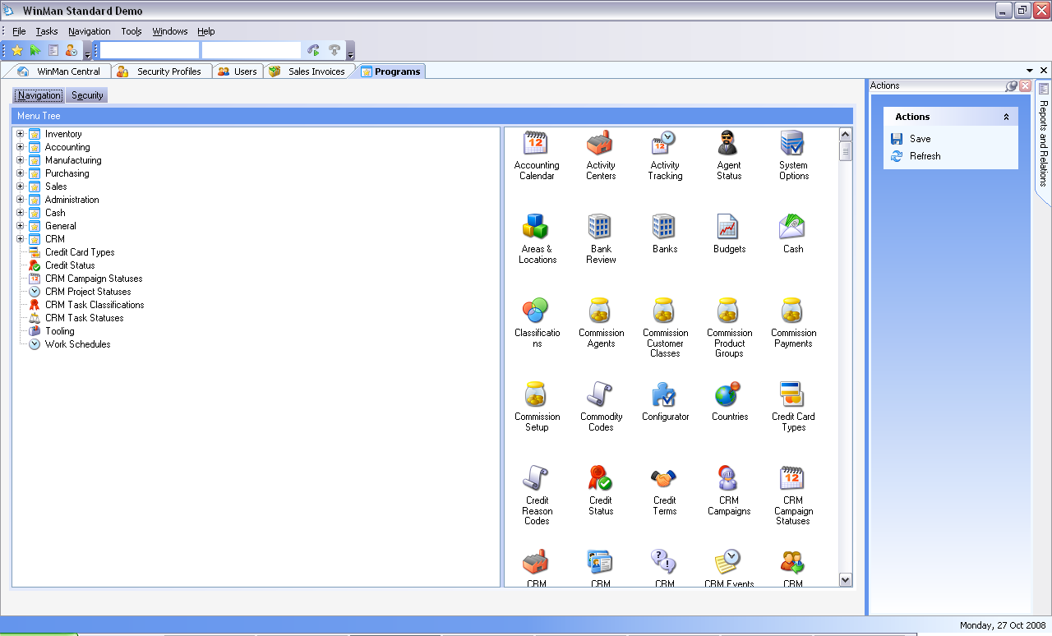

Once the security areas required have been decided select the “Security” tab and you will see System Administrator, My User Settings, Reports which are all locked. Folders have been created and modules have been placed in folders to reflect the same configuration as the navigation tab. To add additional folders, or change the existing configuration, select one of the entries labeled “Undefined”, right click and rename it to the new area e.g.”Sales”. Drag and drop all of the other programs you want to put into “Sales”.
You can continue in this way to set up a maximum of 30 Security Areas.
When you have finished you must remember to choose “Save” from the actions list on the right hand side of the screen before exiting.

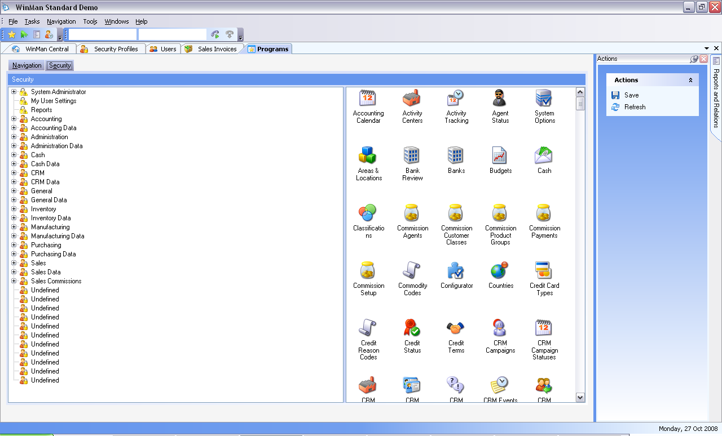
Security Profiles module

The profile provides a method of easily setting a group of users to have the same access rights for all programs.
For example; A sales office where there are 20 clerks who can enter sales orders, but not modify them, but only the supervisor can modify orders and set up new customers, this can be done with two profiles. Perhaps called “Sales” and “Sales Admin”
On the Security Profiles Screen, choose ADD and enter a code and description for the profile. On the Levels tab set System Administrator None, My User Settings Full, and Reports Full.
On the first of the User Levels tabs, the Security areas previously set up will now be showing in place of Undefined, (you may have to refresh). For each of the areas select the appropriate level as decided for the profile.
If you have more than 10 security areas then 11-20 will be found on the second User Levels tab.

The Modify Area action provides a way to change the labels for each of the security areas set up in the Programs module.
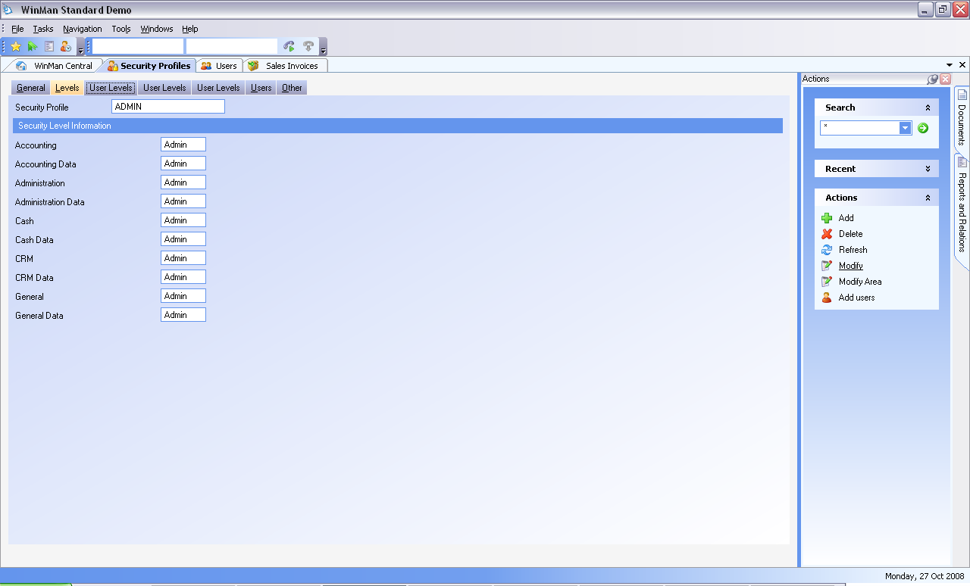

Users

In the Users module, choose ADD and enter a user code, which can be the same as the name. Follow through with the remaining data on the General tab. You will have to enter a password at this stage which the user will have to use the first time they log on to WinMan, thereafter each user can change their own password.

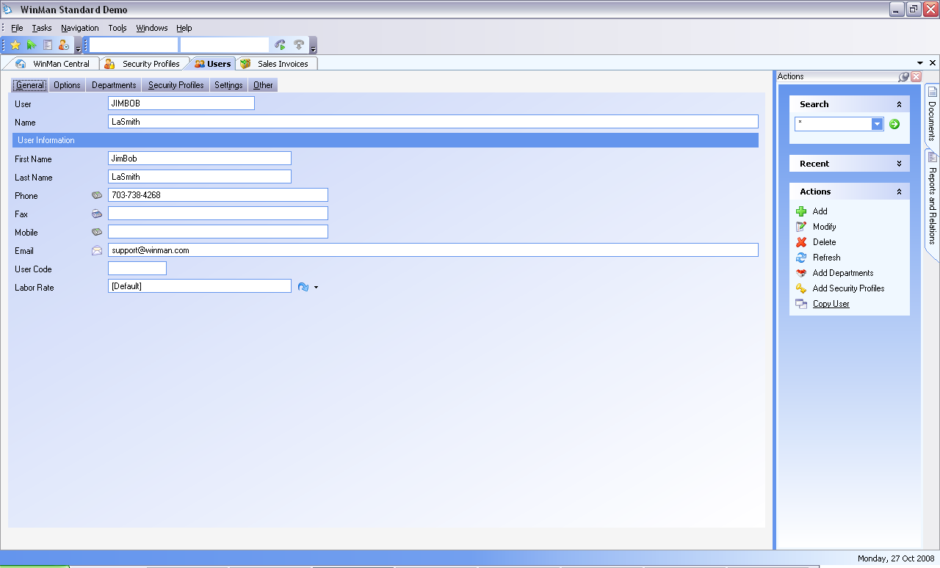

On the Options tab, a user can have their password expire. Once a password has expired the user can no longer log into WinMan. This can be used for temporary or contract workers that have a fixed employment period.

Users must be set to Active and Allow Logon to be able to log into WinMan

A user can have a dashboard (any report) displayed in the dashboard section on WinMan Central. A dashboard must be specified, and the field Show Dashboard must be selected.

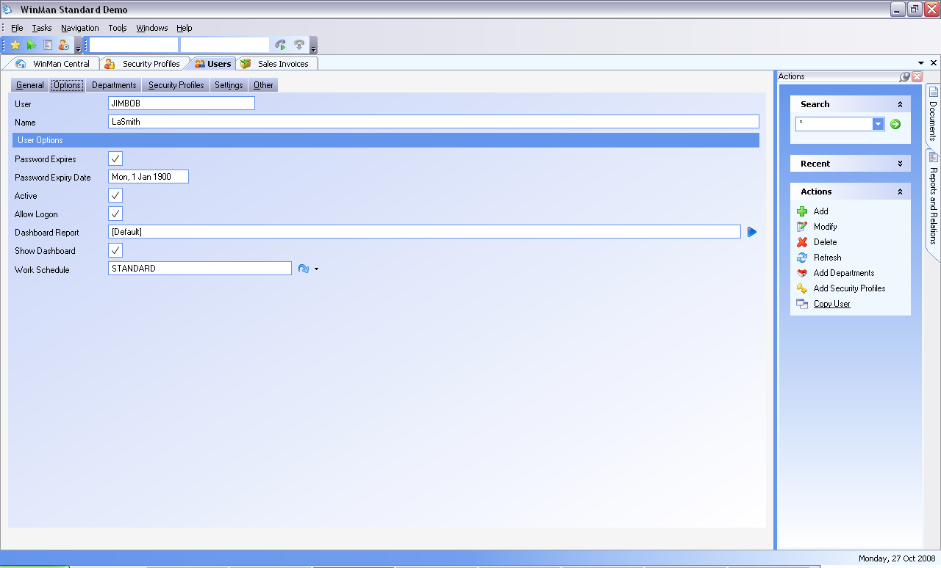

The Departments tab allows for the allocation of a user to a previously specified department, and is not mandatory.
On the security profiles tab, select the action Add Security Profiles and select the required security profile(s) by selecting the include box. A user can have multiple security profiles. In the case where multiple security profiles are selected, and overlap a specific module, the user will receive the highest security setting available in any of the selected security profiles.

